Love your Lake: Lawn Care Tips for the Lake Lover
Spring has sprung, gardens are growing and so are lawns. Here are some simple steps that homeowners can take to ensure a healthy lawn and a healthy lake:
-Leave grass clippings on your lawn. They provide free nitrogen fertilizer for your grass. In general, grass clippings supply all the fertilizer your lawn needs. If a soil sample shows you need additional fertilizer, use a “slow release” form with NO phosphorous. (Lawns need nitrogen.) Fast acting fertilizers are easily washed away into waterways and lakes, providing fuel for unwanted algae growth. Fall is the best time to apply fertilzers, promoting growth the following spring.
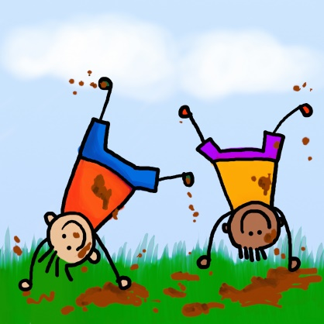
-Weed control can be achieved in several ways. Corn gluten, a nontoxic byproduct of corn processing may be applied early in spring to kill weed seedlings. It also adds a dose of nitrogen to your lawn. You can also target individual weeds with a mixture of 5 parts vinegar, 2 parts water and 1 part dish soap. Spray broadleaf weeds only- the vinegar can burn the grass. (Or use a small amount of herbicide sprayed directly on the weed-not the lawn.) It’s best to treat the weeds when they are small and actively growing.
-Limit pesticide use- or even better, eliminate it completely. Landowners use TEN times more chemical pesticides than farmers! The toxic runoff from the residue percolates in our groundwater, wells and lakes. Children and pets are particularly susceptible to the toxic effects of pesticides and herbicides.
-Mow as needed, but not too short. Most turfgrass is healthiest when kept at 2 ½” – 3 ½’ tall.
-Allow your lawn to go dormant in the hot summer months. It’s best to give grass about ½” of water every other week during dry times. It will bounce back well when the cooler, wetter weather returns. Water early in the morning to avoid water loss to evaporation.
-Replace lawn you don’t use with native plants, shrubs and trees to provide habitat for wildlife and filter water runoff for a healthy lake.

